Express and node

<https://www.udemy.com/course/the-complete-web-development-bootcamp/learn/lecture/12384462#questions/12105158>

Express framework is built on top of node to create backend

Node strictly speaking is not a framework but is a runtime environment- allows us to run JS on computer, not just in the browser

Express is JS framework to create backend for websites

Node is not just limited to web dev can be used to create IoT device , VS code created with node

Express is like an electric screwdriver is to a screwdriver

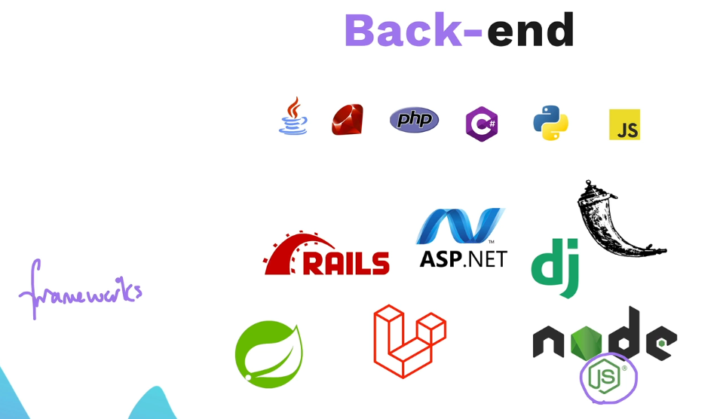

The back end server is just a computer on 24/7, with an application loaded in it even if just an html file and usually a database.

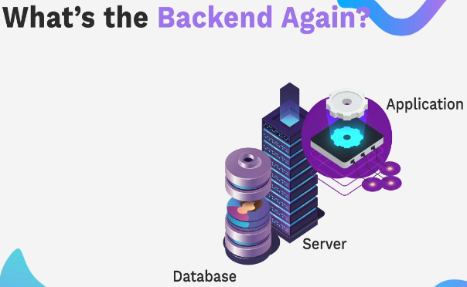

Client makes requests of the sever

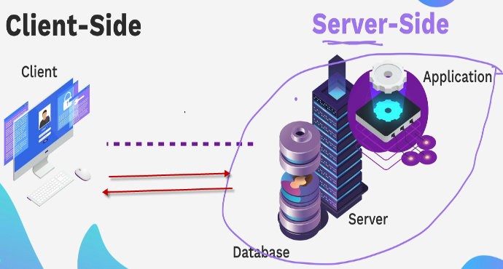

Backend is server side

Our application will be done with Express / Node (express to help with node)

Will run server locally

6 steps to make express server

Localhost is my computer

Port is like a door to server – can have many doors for many services running at same time. 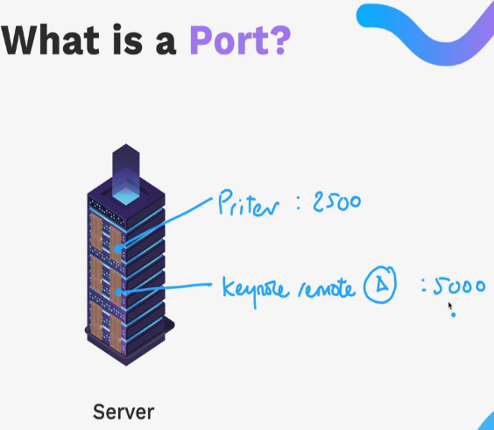

Command line to determine what ports are listening

HTTP requests

Hypertext Transfer Protocol – a that allows computers to talk to each other over the internet.

Express methods

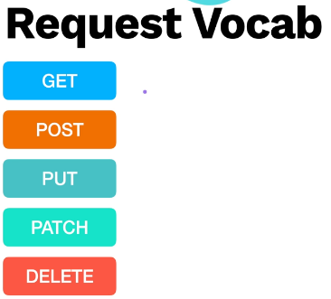

Get - request a resource from the server

Post – send a resource to the server

Put – update by replacing entirely

Patch – update by patching up, not a full replace

Delete – delete from the server or the database

Request comes in from browser on a particular path accessible in anonymous function , able to send back response. res.send ()

Nodemon so server is restarted with changes

Endpoints



/ is the home page

Section 204 Using postman

Responses are in 5 categories

https://developer.mozilla.org/en-US/docs/Web/HTTP/Status

Capturing a re direct in the console

HTTP request methods

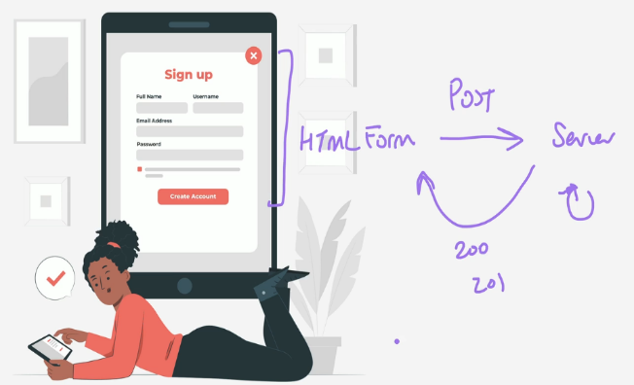

Postman helps because we need the front and back end



Middleware

**

Sits between the raw request and route handlers

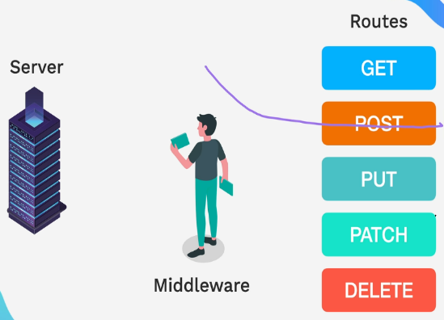

Middleware can perform actions on the request before it goes on to routing

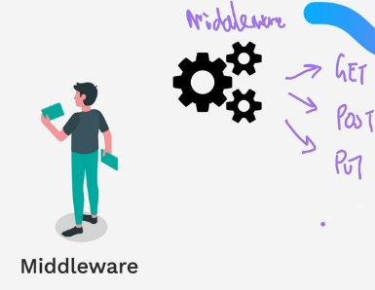

Can use middleware to log the request, get status , do authentication or process errors 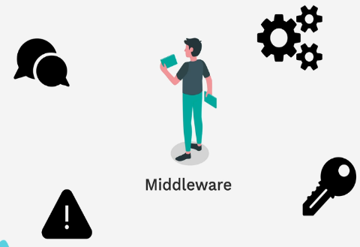

Body Parser is a popular middleware

<https://www.npmjs.com/package/body-parser>

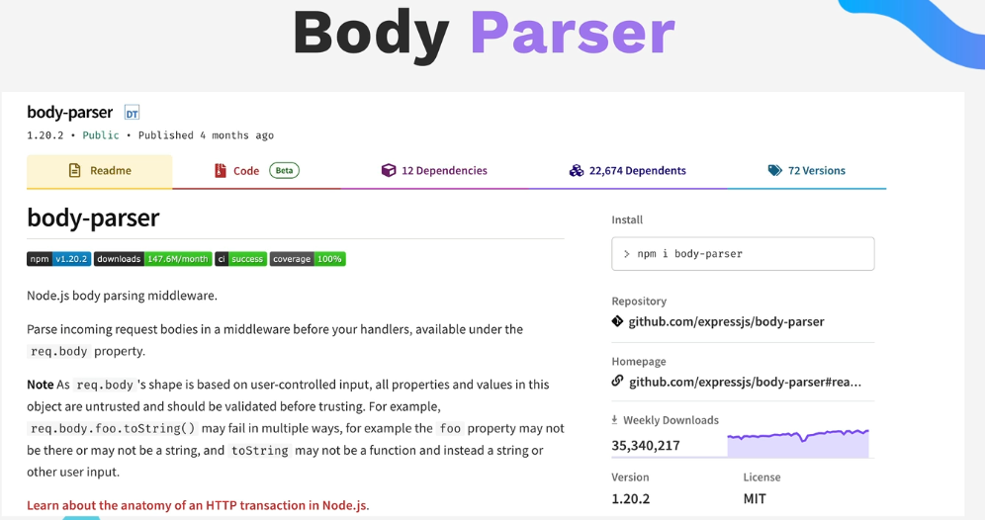

What does body parser do –

It gives a request a new property called body property.

Commonly used to handle form data input by user – parse the request

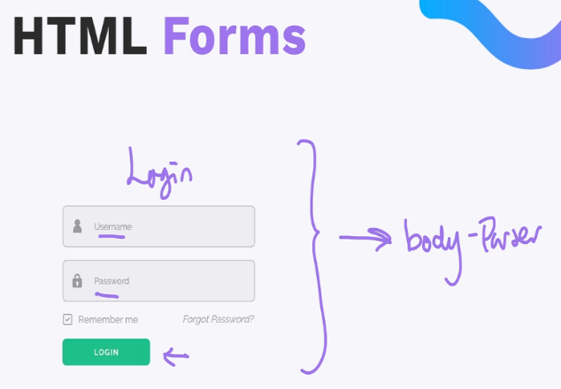

Form data action is the route, method is the route

Input key value pairs, type:text, name:email

Public folder is generally the place for static files.

Return index.html from the server – express res send file Use node and express to dynamically get to public folder holding index.html

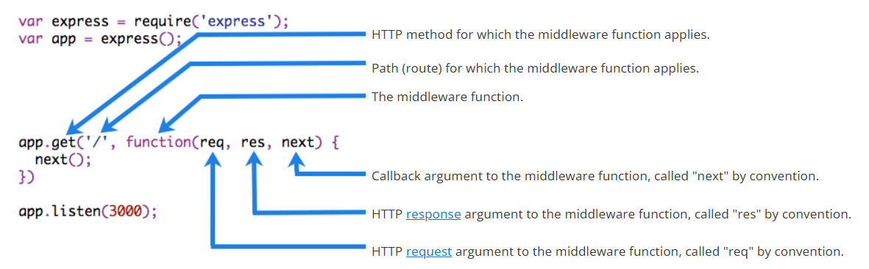

Node and express dynamic file path

Body Parser

Use body parser to parse the information coming in from the form.

Form submit button makes post request

Need a route handler to handle the post request to path body parser will parse the information that comes in from the HTML form . Add data to the request object then console.log in req.body

The use method gets called before any of the route handlers

Tell body parser what kind of data, Html form uses urlencoded

By using body parser the req now has a body

The get handler sends back a resource the user wants, for the form data need a post to send to the server

Custom Middleware –

4 types of middleware Body Parser is pre processing type, Morgan is a logging type 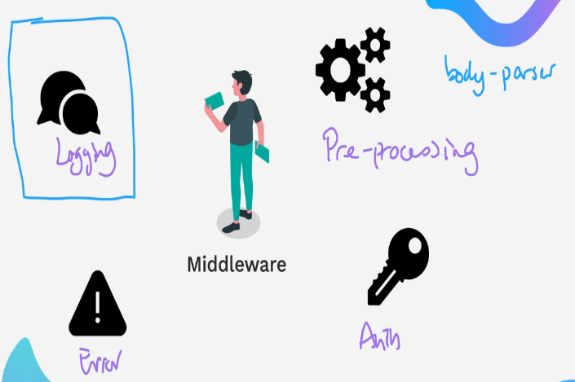

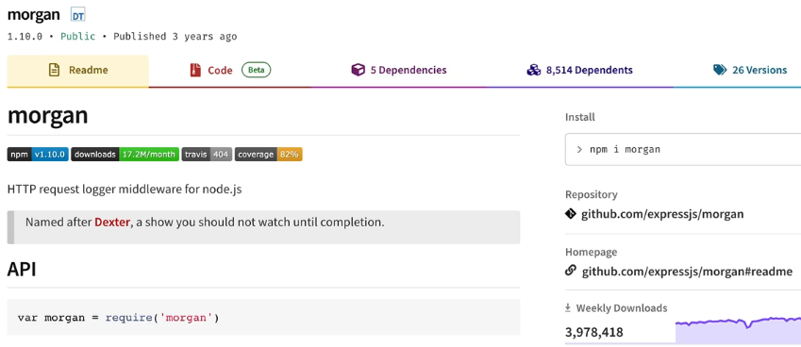

Morgan logs requests that come in to the server

After import add using app.use() method

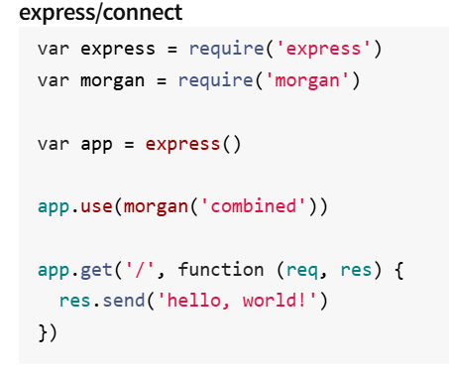

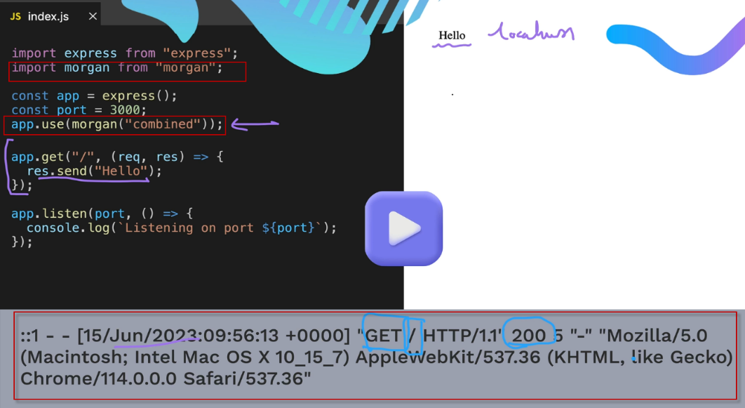

DYI middleware

Band Name

Secrets Access Project –

Create web site

My sol works but if wrong site just spins – so did the provided solution

Restart here

<https://www.udemy.com/course/the-complete-web-development-bootcamp/learn/lecture/38911668#questions/12105158>